EUROPEAN COMMISSION – FCH JU

HORIZON 2020 PROGRAMME - TOPIC H2020-FCH-02-4-2019

New Anion Exchange Membrane Electrolysers

GRANT AGREEMENT No. 875024

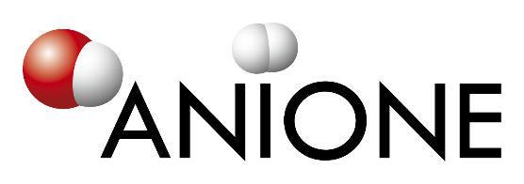

Anion Exchange Membrane Electrolysis for Renewable Hydrogen Production on a Wide-Scale

ANIONE – Deliverable Report

D8.1 – NEC - Requirement No.1

|  |  |  |
| --- | --- | --- |
| **Deliverable No.** | ANIONE D8.1 |  |
| **Related WP** | WP8 |  |
| **Deliverable Title** | NEC - Requirement No.1 |  |
| **Deliverable Date** | 31-12-2020 |  |
| **Deliverable Type** | Ethics |  |
| **Dissemination level** | Confidential – member only (CO) |  |
| **Lead Beneficiary** | CNR-ITAE |  |
| **Author(s)** | Anna Molinari (UNR)  Eva Bøgelund (UNR)  Antonino Aricò (CNR-ITAE) | 04-02-2021 |
| **Checked by** | All partners | 15-02-2021 |
| **Reviewed by** | All partners | 15-02-2021 |
| **Approved by** | Antonino Aricò (CNR-ITAE) – Project Coordinator |  |
| **Status** | Final |  |

Disclaimer/ Acknowledgment

Copyright ©, all rights reserved. This document or any part thereof may not be made public or disclosed, copied or otherwise reproduced or used in any form or by any means, without prior permission in writing from the ANIONE Consortium. Neither the ANIONE Consortium nor any of its members, their officers, employees or agents shall be liable or responsible, in negligence or otherwise, for any loss, damage or expense whatever sustained by any person as a result of the use, in any manner or form, of any knowledge, information or data contained in this document, or due to any inaccuracy, omission or error therein contained.

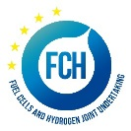

All Intellectual Property Rights, know-how and information provided by and/or arising from this document, such as designs, documentation, as well as preparatory material in that regard, is and shall remain the exclusive property of the ANIONE Consortium and any of its members or its licensors. Nothing contained in this document shall give, or shall be construed as giving, any right, title, ownership, interest, license or any other right in or to any IP, know-how and information.

This project has received funding from the Fuel Cells and Hydrogen 2 Joint Undertaking (JU) under grant agreement No 875024. This Joint Undertaking receives support from the European Union’s Horizon 2020 research and innovation programme, Hydrogen Europe and Hydrogen Europe research. The information and views set out in this publication does not necessarily reflect the official opinion of the European Commission. Neither the European Union institutions and bodies nor any person acting on their behalf, may be held responsible for the use which may be made of the information contained therein.

**Publishable summary**

D8.1 describes the ethics requirements of the ANIONE project. Within the project, samples will be shipped between project partners. As two partners (Hydrolite, formerly PoCellTech; TFP Hydrogen Materials Limited, formerly PV3) are located in non-EU countries (Israel and United Kingdom, respectively) the materials that are imported and exported from the EU as part of the ANIONE project need to be documented. This deliverable provides an overview of the material that will be imported/exported as part of the ANIONE project and describes what kind of details related to these materials will be documented.

Contents

1 Introduction 3

2 Approach 3

2.1 Documentation of imported and exported material from EU 3

2.2 Procedure to exchange project-related material 4

3 Conclusions 5

Acknowledgement 6

Annex A – Authorisation Documents 7

Annex B – Quality Assurance 10

# Introduction

The ANIONE project aims to develop a high-performance, cost-effective and durable anion exchange membrane water electrolysis technology. During the project, material samples will be shipped between partners. As two partners (Hydrolite, formerly PoCellTech; TFP Hydrogen Materials Limited, formerly PV3) are located in non-EU countries (Israel and United Kingdom, respectively) the materials that are imported and exported from the European Union as part of the ANIONE project need to be documented. Deliverable 8.1, part of WP8, summarises the materials that will be exchanged between partners as part of the ANIONE project and describes what kind of details related to these materials will be documented.

# Approach

## Documentation of imported and exported material from EU

The ANIONE research involves partners from non-EU countries. Specifically, exchange of material between project partners Hydrolite (formerly PoCellTech) and TFP Hydrogen Materials Limited (formerly PV3), located in Israel and United Kingdom, respectively, and the other project partners require the import and export regulations to non-EU countries to be considered. An important aspect that needs to be documented is the type of material that is being exchanged. Within the ANIONE project, a spreadsheet will be used to document and log this. The following will be documented in this spreadsheet:

|  |  |  |
| --- | --- | --- |
|  | **Name** | **Description** |
| **1a** | WP provision | Related WP where material is provided and if possible related task |
| **1b** | WP use/testing | Related WP where material is used/tested and if possible related task |
| **1c** | Related deliverable/milestone |  |
| **2a** | Requesting org. | Short name of requesting organisation |
| **2b** | Country of requesting org. | Country code of the requesting organisation. Indicate if country is EU member |
| **3a** | Providing org. | Short name of providing organisation |
| **3b** | Country of providing org. | Country code of the providing organisation. Indicate if country is EU member |
| **4a** | Material | Type/name of material |
| **4b** | Quantity | Indicate the quantity of material (e.g. volume, mass, number of items). |
| **5** | Date of request | Date of request by requesting organisation |
| **6** | Date of supply sent | Date of supply sent by providing organisation |
| **7** | Contact info requestion org. | Name, email, phone number |
| **8** | Contact info providing org. | Name, email, phone number |
| **9** | Comment | E.g., material batch number, relevant safety manuals and/or datasheets, other relevant documents |

The project management tool METT will be used as platform for the project partners to exchange and archive these material exchange documents. In addition, partners have agreed to obtain and keep copies on file of import/export authorisations as required by national and EU legislation (see Annex A).

A summary of the materials each project partner will import/export is provided below.

|  |  |  |  |  |
| --- | --- | --- | --- | --- |
| **Partner** | **Material provided** | **Country** | **EU/other** | **Comment** |
| CNR-ITAE | * FAA3-50 (Lot no. M35351903) Cl- * FAA3 Shredded film * FAA3-50 (membrane lot n° M35351903) Br- * NiFe LDH catalyst * Ni-catalyst * NiCu * NiFe LDH catalyst | IT | EU | 2 A4 sheets of membranes and 2 g of shredded films supplied to Hydrolite (formerly PoCellTech) with authorization document (protocol number 0003034/2020 of 15-Dec-2020).  5g Ni-based anodic catalyst and 5 g Ni-based cathodic catalyst to be supplied to TFP Hydrogen Materials Limited (formerly PV3) |
| CNRS |  | FR | EU |  |
| Hydrolite (formerly POCELLTECH) | * Membrane in Br- form * Ionomer in HCO3- form * PoCellTech ionomer powder * PoCellTech membrane | IL | Other | It is estimated an amount of 1-2 m2 of polyarylene based membranes and 20g of ionomer for the entire project |
| TFP Hydrogen Materials Limited (formerly PV3) | - Mo2C  - NixFeyOz | UK | EU | 2 g of benchmark Mo2C and NixFeyOz supplied to CNR-ITAE |
| IRD | * NiCo-spinel, from C-tech * MMO, from C-tech * NiCo-spinel, from C-tech * NiCo-spinel, from C-tech * NiFe-catalyst, from CENmat * Mo2C, from CENmat | DK | EU |  |
| HYDROGENICS |  | BE | EU |  |
| UNIRESEARCH | n/a | NL | EU | No material exchange |

## Procedure to exchange project-related material

The following procedure for exchange of materials used in the ANIONE project will be followed:

1. All partners will specify what material they will be exchanging during the ANIONE project and inform the management team (using the log spreadsheet).
2. Partners wishing to exchange material with Hydrolite (formerly POCELLTECH) or TFP Hydrogen Materials Limited (formerly PV3) must contact their own legal and security officers, with the aim to get information on national legislation concerning import/export to non-EU countries.
3. All necessary documents (security certificates, transportation certificates, safety data sheets, etc.) will be acquired by the partners wishing to exchange material.
4. All relevant documents will be stored on METT. The management team will provide them upon request to the EC.

# Conclusions

This deliverable summarises the material that will be import/export from the EU as part of the ANIONE project. It describes the information that will be documented and the procedure to be followed for the exchange of materials between partners for use in the ANIONE project. There are no deviations from the description of this deliverable as given in Annex 1 of the Grant Agreement.

# Acknowledgement

The author(s) would like to thank the partners in the project for their valuable comments on previous drafts and for performing the review.

**Project partners:**

|  |  |  |
| --- | --- | --- |
| # | Partner | Partner Full Name |
| 1 | CNR-ITAE | CONSIGLIO NAZIONALE DELLE RICERCHE |
| 2 | CNRS | CENTRE NATIONAL DE LA RECHERCHE SCIENTIFIQUE |
| 2.1 | UM | UNIVERSITE DE MONTPELLIER |
| 3 | HydroLite (formerly PoCellTech) | HYDROLITE |
| 4 | PV3 | PV3 TECHNOLOGIES LTD |
| 5 | IRD | IRD FUEL CELLS A/S |
| 6 | HYDROGENICS | HYDROGENICS EUROPE NV |
| 7 | UNR | UNIRESEARCH BV |

|  |  |  |
| --- | --- | --- |
|  | *This project has received funding from the Fuel Cells and Hydrogen 2 Joint Undertaking (JU) under grant agreement No 875024. This Joint Undertaking receives support from the European Union’s Horizon 2020 research and innovation programme, Hydrogen Europe and Hydrogen Europe research.* | http://elastic.studioh2o.nl/image.php/userdata/image/ec_1.gif?width=150&height=150&image=/userdata/image/ec_1.gif |

# Annex A – Authorisation Documents

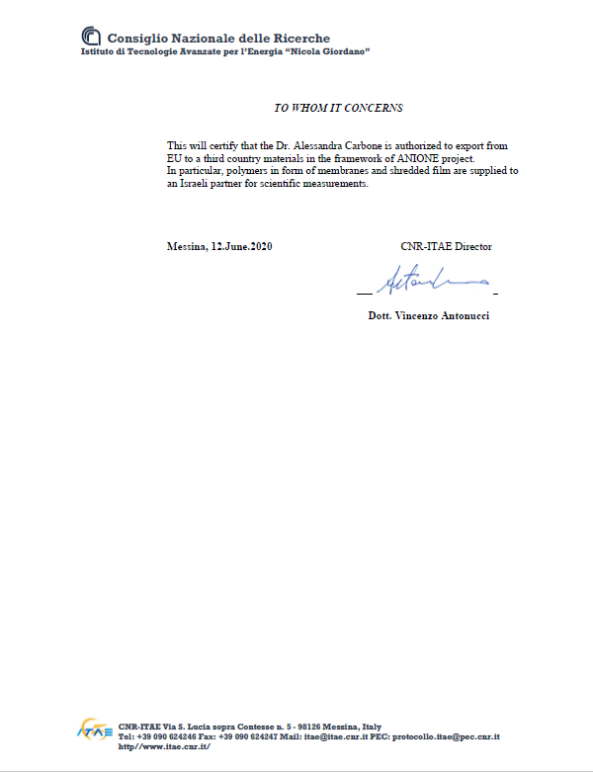

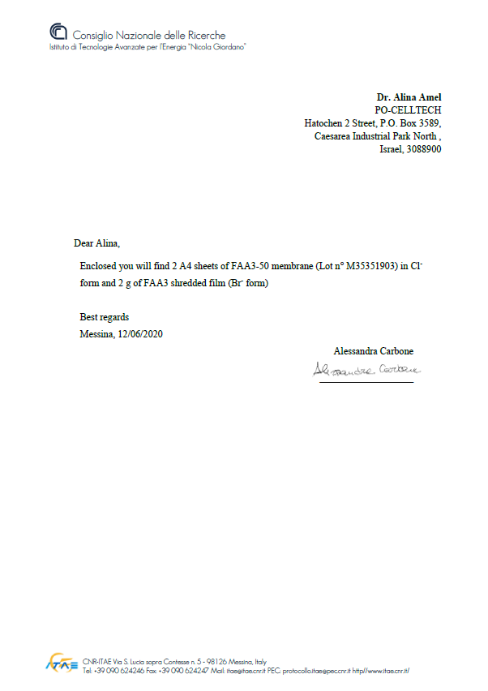

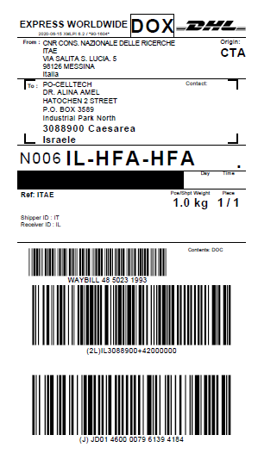

# Annex B – Quality Assurance

NOTE: For public documents this Quality Assurance part will be removed before publication.

The Lead Beneficiary can also opt to remove the Quality Assurance Table.

The following questions should be answered by all reviewers (WP Leader, peer reviewer(s), and the Project Coordinator) as part of the Quality Assurance Procedure. Questions answered with NO should be motivated. The author will then make an updated version of the Deliverable. When all reviewers have answered all questions with YES, only then the Deliverable can be submitted to the EC.

|  |  |  |  |
| --- | --- | --- | --- |
| Question | Author | Peer reviewer(s) | Project Coordinator |
|  | UNR | All partners | Antonino Aricó |
| 1. Do you accept this Deliverable as it is? | Yes | Yes | Yes |
| 1. Are all required actions from the DoA performed and reported in the Deliverable? | Yes | Yes | Yes |
| 1. Are all interactive outputs clearly defined for the related Tasks? | Yes | Yes | Yes |
| 1. Is the Deliverable complete  - omissions / all required chapters /- argumentation | Yes | Yes | Yes |
| 1. Is the technical quality sufficient?   - inputs and assumptions correct - data, calculations and motivations correct - outputs and conclusions correct | N/A | N/A | N/A |
| 1. Are the tasks/WP/project objectives clearly addressed in the Deliverable? | Yes | Yes | Yes |
| 1. Is created and potential IP identified and are protection measures in place? | N/A | N/A | N/A |
| 1. Is the Risk Procedure followed and reported? | Yes | Yes | Yes |
| 1. Is the reporting quality sufficient?  - clear language - argumentation - consistency - structure - use of templates, etc | Yes | Yes | Yes |
| 1. Is the Deliverable formatted according to the project template? | Yes | Yes | Yes |
| 1. Is the Deliverable ready? | Yes | Yes | Yes |